**K-Means** Clustering is an unsupervised learning algorithm that is used to solve the clustering problems in machine learning or data science. In this topic, we will learn what is K-means clustering algorithm, how the algorithm works, along with the Python implementation of k-means clustering.

K-Means Clustering is an [Unsupervised Learning algorithm](https://www.javatpoint.com/unsupervised-machine-learning), which groups the unlabeled dataset into different clusters. Here K defines the number of pre-defined clusters that need to be created in the process, as if K=2, there will be two clusters, and for K=3, there will be three clusters, and so on.

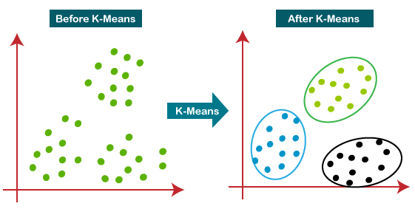

Elbow Method

The Elbow method is one of the most popular ways to find the optimal number of clusters

**Hierarchical clustering** is another unsupervised machine learning algorithm, which is used to group the unlabeled datasets into a cluster and also known as **hierarchical cluster analysis** or HCA.

In this algorithm, we develop the hierarchy of clusters in the form of a tree, and this tree-shaped structure is known as the **dendrogram**.

Sometimes the results of K-means clustering and hierarchical clustering may look similar, but they both differ depending on how they work. As there is no requirement to predetermine the number of clusters as we did in the K-Means algorithm.